WEB DEVELOPMENT COURSES (WBC) PROJECT

Software Requirements Specification

|  |  |  |  |
| --- | --- | --- | --- |
|  | Prepared By | Reviewed By | Approved By |
| Name | Sreeja Saha | Devathilagai |  |
| Role | Interns | Batch Trainer |  |

**Table of Contents**

Table of Contents…………………………………………………………..….......II

1. Introduction…………………………………………………………………..…1

1.1 Intended Audience……………………………………………….......1

1.2 Project Scope…………………………...……………………………1

2. Overall Description…………………………………………….……………….1

2.1 Operating Environment……………………...……………………....1

3. Requirements……………………………………………………………...…….1

3.1Login………………………………………………………………….2

3.1.1Description………………………………………………....2

3.1.2 Functional Requirements……..…………………………...2

**1. Introduction**

[Zig Wheels is a popular car and bike research platform in India](https://www.zigwheels.com/aboutus). [It provides comprehensive information, price alerts, and offers about new and used cars, motorcycles, and scooters](https://www.zigwheels.com/aboutus). [Users can compare any two cars or bikes to make an informed buying decision](https://www.zigwheels.com/aboutus)

**1.1 Intended Audience**

Business Unit (BU) SME

Academy coach

Technical Trainer

**1.2 Project Scope**

This document defines at a functional level the business activities that are encompassed by the system and the rules that apply to them. It also encompasses some of the key high and low level technical requirements of the system.

It draws heavily on both proposed Framework and Business Rules and the Technical Architecture documents. The scope of the detailed analysis project phase specifies that this document will include.

· Classification of requirements according to their functional areas.

· A description of each process in the system, including their inputs, outputs, and data transformation rules.

**2. Overall Description**

**2.1 Operating Environment**

Windows operating system

Web application

**3. Requirements**

This section of the requirements document presents the "Identify New Bikes" feature of the Zig Wheels program. In addition, we must extract all used cars from "Chennai" and check for the incorrect login credentials.

**3.1.1 Functional Requirements**

**3.1.1.1 Req0001**

**Req0001a--** The user is on the Zig Wheels website and selects Upcoming Bikes from the dropdown.

**Req0001b**-The user sets the filter Manufacturer to Honda and user clicks on the View More button.

**Req0001c-**The user should filter out the displayed Honda bikes with a price less than 4Lac.

**Req0001d-** For each bike priced under 4Lac should be added to their respective lists.

**3.1.1.2 Req0002**

**Req0002a**- The user hovers over the Used Cars link.

**Req0002b**- The user selects Chennai from the dropdown.

**Req0002c-** The user scrolls down to the list of popular models.

**Req0002d-** The user should extract all the popular models in a List.

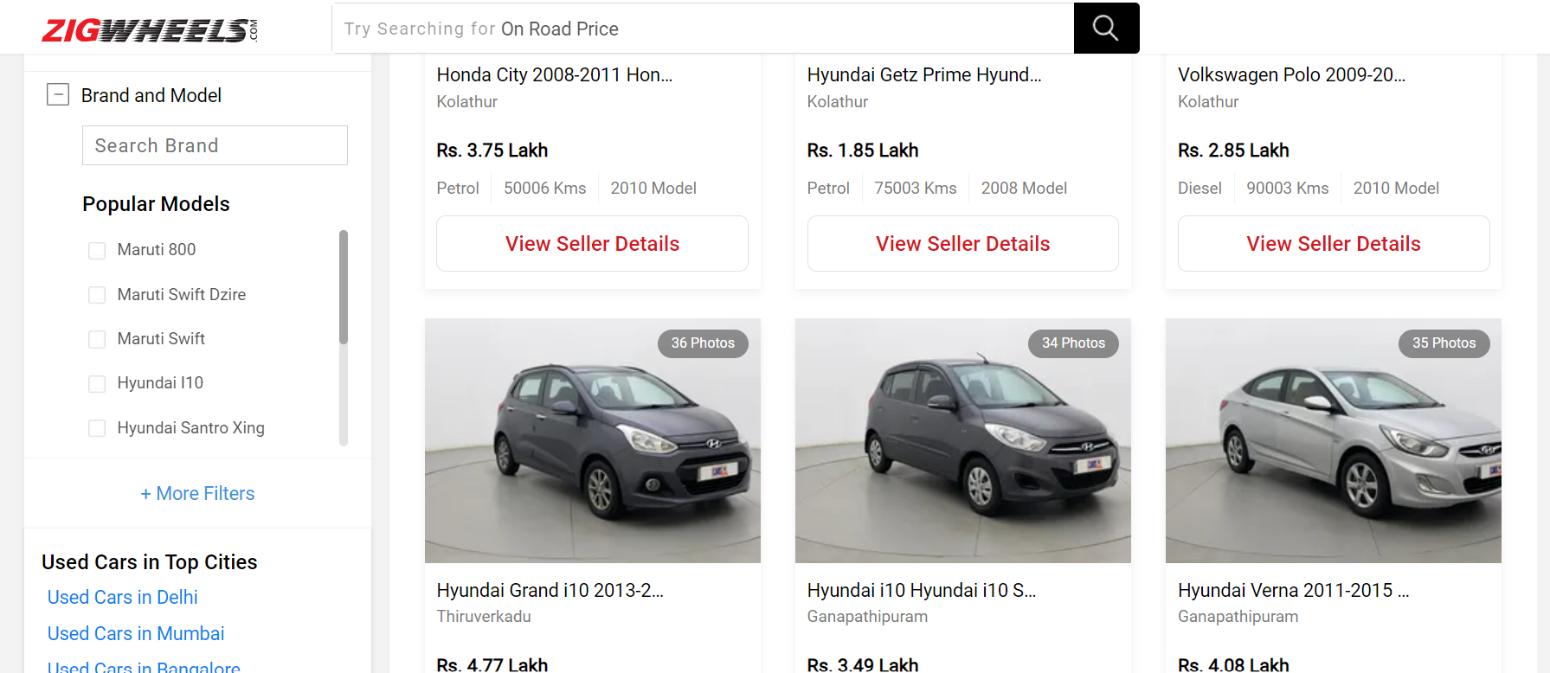

**3.1.2.3 Req0003**

**Req0003a**-click the “Login Button” which will take to page.

**Req0003b-** Click the google button.

**Req0003c-**It will navigate into new window and the google login will appear.

**Req0003d-** the user enters the Invalid emailId and clicks on the Next button and system should display error message.

